Milestone project description

Written by Alex Zoller

June 6, 2021

CST-341

JQuery Framework implementation.

For milestone 6, the implementation of JQuery is needed. We decided to update most of the lists, and mainly used pages. With this, the speed of the application is faster. While before the application would wait for the back end to receive data to display the page. Instead, the application loads the page and receives the data, once receive loads it to the displayed page. This is a common use age of the JQuery application limitations and usages. Here are the photos of the application in action:

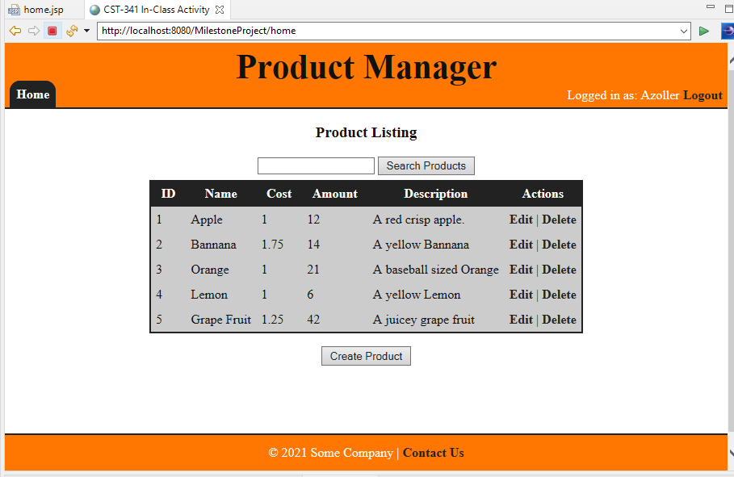

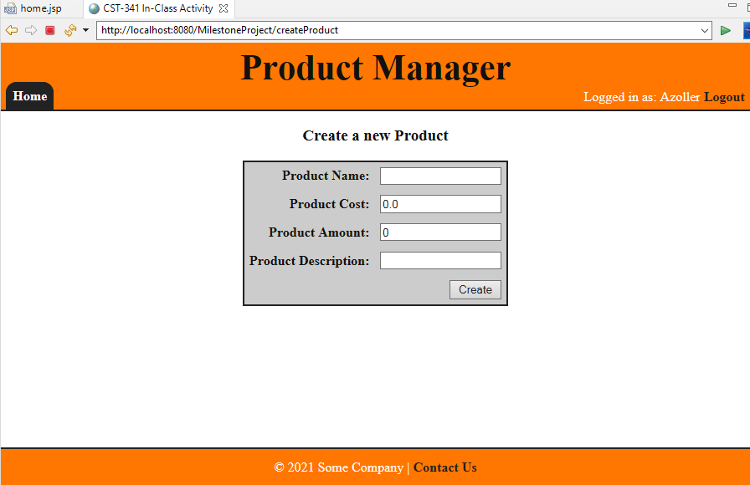

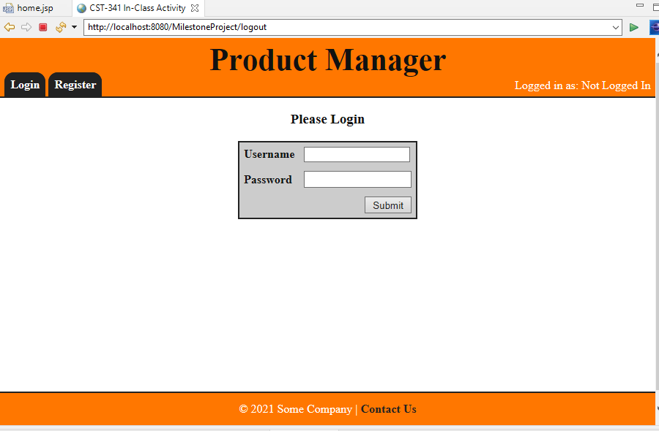

For our the CLC-Milestone project as a group, we chose to develop an inventory manager web application. To start off, the direction we are following is based in the project guide. We are adopting and developing our application following the N-Layer enterprise levels. 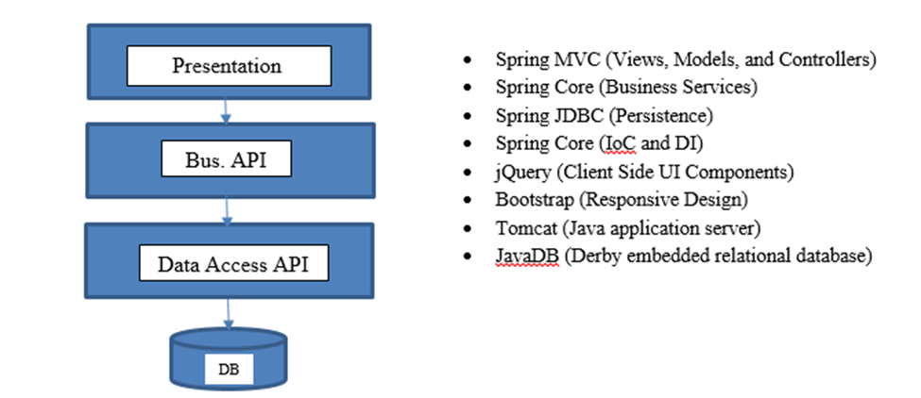

With these intergraded into the application, we are planning to use these to their advantages in the inventory manager application. The application will follow the general format of containing but not limited to:

-Login page

-Registration page

-All products page

-Create new product page

-Display details of a product page

-Update existing product page

-Delete existing product

As for storing all of this information containing the products and user we are using a remote database. Hosted from a website called RemoteMysql.com. This enables us to be able to have a database running all the time, also we can all access the same database as a group. This will improve development and coordination. Here is the information to access and login the database:

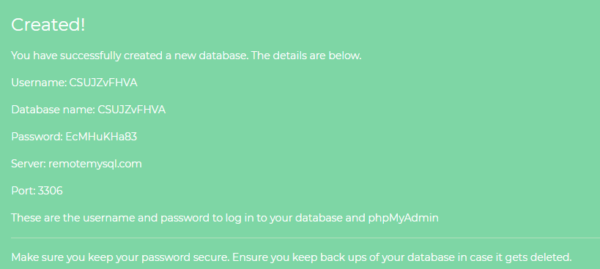

The structure of the database will include the primitive objects that are used to create the User and Product object. We will also include an export of the database to show off the structure of the database and the correct names given and the key set as for each table.

